**Instructions**

* Read the following information about the Textile Museum of Canada. This will be used for our group activity on Friday.
* **Individually**, you are to come up with at most three projects that you think the museum should do in order to achieve its stated objectives. Type these projects up using the template found at page 7 of this exercise. **Do not change the font size or the layout!** These three projects that you come up INDIVIDUALLY at this stage will be submitted to me will be graded as part of a quiz. This is an INDIVIDUAL 10 point quiz.
* **Students who come unprepared on Friday during class will not be able to join the group discussion which is ANOTHER 10 point quiz.**

**The Textile Museum of Canada**

The Textile Museum of Canada is one of Toronto's most engaging visual arts organizations.  With more than 12,000 objects from more than 200 countries and regions, the TMC's permanent collection celebrates cultural diversity and includes traditional fabrics, garments, carpets and related artifacts such as beadwork and basketry.  The Museum offers a broad variety of exhibitions including themed shows based on our permanent collection and contemporary exhibitions of the work of Canadian and international artists.

Incorporated in 1975 as the **Canadian Museum of Carpets and Textiles**, the TMC first presented its collection in a very modest room in Toronto's Mirvish Village. In 1989 they celebrated the opening of a new facility at 55 Centre Avenue. Now known as the **Textile Museum of Canada**, the TMC has gained international recognition for the quality and importance of its [collection](http://www.textilemuseum.ca/collection), the excellence of its [exhibitions](http://www.textilemuseum.ca/exhibitions) and [programming](http://www.textilemuseum.ca/apps/index.cfm?page=whatsOn.home). Visitors to the galleries can experience the traditions, skills and creative processes that make textile arts so engaging.

**Visit fibrespace, our permanent hands-on gallery** where guests are introduced, in both physical and tactile ways, to the many ways textiles influence their lives.  Touch and explore the properties of cloth and see the endless possibilities of pattern and decoration.  In fibrespace visitors will - discover fibre, discover colour, discover textiles and discover meaning.

**Open seven days a week**, the TMC is in the heart of downtown Toronto steps from the St. Patrick subway station and several blocks from the Eaton Centre, Toronto City Hall, and the Art Gallery of Ontario.

**Mission**

The Textile Museum of Canada's mission is to engage the public in the discovery, appreciation and understanding of diverse cultural experiences through the art and craft of textiles, both past and present, and through this rich lens advance understanding of local and global issues.

**Vision**

The Textile Museum of Canada will excel as a national cultural institution anchored in the  
local community, ensuring relevance through our ability to reflect the evolving richness and diversity of cultural experiences through the materials of everyday lives, and engaging national and international audiences through the agility and responsiveness of innovative research, exhibition and educational programs.

**Values**

The Textile Museum of Canada is guided by four key personal and professional values:

**Respect**

We are audience/visitor centred and provide an accessible, welcoming environment for visitors, volunteers, members and staff

We foster generosity of spirit

We believe in community and cultural diversity

We respect the contributions of individuals

**Excellence**

We practice high museological standards as we preserve and promote textiles of worldwide significance

We foster a culture of philanthropy

We value a healthy and sustainable organization

**Knowledge**

We are committed to life-long learning

We reach out to a broad sector of the population through our core programs

We offer a model of museums as sites of knowledge and platforms for knowledge-generation, producing new understanding through our exhibitions, programs and digital initiatives.

We play a key role in the broader arts ecology, mentoring and training new generations and offering opportunities for creative and scholarly research

**Innovation and Agility**

We nurture research and artistic creativity, facilitating new perception through a range of media and activities

We readily embrace a diversity of communities and opinions that enhance and expand an institutional culture focused on community relevance and engagement

We are an agile, responsive partner to a range of collaborators, disciplines and sectors.

We are a leader in new technology development and the integration of mobile platforms in the cultural and heritage sector.

**STRATEGIC PLAN**

**Executive Summary**

**Connecting Cloth, Culture & Art**

**Executive Summary** *2012 to 2016*

For over three decades, the Textile Museum of Canada (TMC) has established itself as one of Canada's most engaging visual arts organizations with a reputation for fostering both knowledge and creativity and wide acclaim from local and international audiences. Now approaching its 40th anniversary, it was timely to frame the Museum's direction in order to align all aspects of Museum activity and communicate this vision to the arts community and the public at large. To this end, the Textile Museum of Canada undertook the development of a strategic plan in 2012 based on a renewed vision for the organization, establishing priorities for the period 2012/13 to 2015/16. The goal of this plan is to ensure the effective investment of human and financial resources and to frame the direction of the Textile Museum and guide its development.

With a collection of over 12,000 artifacts from over 200 world-regions, the Textile Museum's capacity to reflect upon the universal relevance of textiles as well as leading artistic practices that continue to push the boundaries of the medium has broadened the Museum's scope and significance. Initiatives planned over the next years will continue to situate the TMC and its collections and exhibitions within broader interdisciplinary conversations.

An international repository of human heritage, archaeological to contemporary, the Textile Museum of Canada features creative practices that connect local experiences to global ideas and issues. The organisation's current direction highlights the Museum's unique capacity to speak to evolving cultural experiences in a global context and our increasingly global communities, and the TMC's active and integral role in conversations about culture and cultural history in the 21st century.

**The strategic planning process identified the Textile Museum of Canada's distinct strengths:**

1. The Museum is thoroughly interactive. It is agile, both "high touch" - allowing for interaction with its collections, and "high tech" - integrating innovative digital platforms.

2. The Museum provides a unique lens combining textile arts and technology through which to understand local and global cultural experiences and celebrate human creativity and ingenuity.

3. The Museum builds knowledge through responsive interdisciplinary exploration and scholarship.

4. The Museum promotes both historical and contemporary perspectives through its collections, preservation, interpretation, and presentation of new artistic practices.

5. The Museum values social inclusion and social justice, which are reflected in all its activities.

Among its values, the Textile Museum of Canada is audience/visitor centred with a strong belief in community and cultural diversity, reaching out and responding to a broad sector of the population through our core programs and promoting an understanding of human identity through textiles.

Our exhibitions showcase objects from our collections, encompassing 2000 years and over 200 countries and regions, as well as contemporary interdisciplinary creative practices, and our educational programs are designed to foster an awareness and understanding of these cultures through hands-on activities, lectures, tours and special events.

Receptive and responsive, through partnerships and interaction with local, national and international communities as well as other museums and galleries, the Textile Museum of Canada has become an innovator in globally relevant, multi-disciplinary knowledge generation, a place where individuals can come together to share experiences, contributing to knowledge and cultural activity through the institution.

**Strategic Focus and Objectives:**

The strategic planning process identified five key strategic goals, also highlighting the activities required to achieve each goal, performance targets, and metrics of success.

1. Ensure leading-edge facilities that support the Museum's collection development and conservation, as well as community and professional activities.

2. Expand relationships, increasing and stabilizing revenues through new corporate, private and public sector funding and new streams of earned revenue to support the Museum's collecting, conservation and exhibition activities.

3. Raise the profile of the Museum with potential funders, partners, and the general public through our responsiveness and the quality of our interdisciplinary and innovative programs and exhibitions.

Strategies:

* Continue to promote new brand image and key messages
* Maximize limited marketing resources towards activities of a scale and nature that return the most significant benefits
* Connect to new audiences and leverage growing customer base with grassroots and direct marketing activity; focus on increasing its capacity in this area
* Broaden our markets and networking potential through effective online promotions; leveraging investments made in the development of TMC online presence
* Expand local street banner program, further increasing general awareness of the Museum for both residents and commuters
* Invest in advertising and promotions to reach greater numbers of out-of-town visitors
* Increase and broaden membership and attendance through comprehensive planning
* To develop and sustain the Museum's foundation as an educational institution committed to lifelong learning
* Continue to improve the high standard of delivery in all the Museum's programs
* Work with the other centres to find more ways to increase the Museum's ability to draw participants in for our programs
* Work with development staff to find ways to fund and support the educational programs
* Develop efficiencies in planning and delivery of programs, especially lectures, panels and performances
* Increase opportunities for family-friendly and youth programming

4. Continue to broaden access to the TMC's collections and build on our unique ability to connect physical and virtual experiences, enriching intimate face-to-face encounters with information-rich artefacts with emergent insight supported by leading digital initiatives.

5. Build capacity across facets of the TMC's operations by increasing resources to expand the staffing and support in priority areas.

Institution wide Strategies:

* Practice excellence in human resource management and development for both staff and volunteers
* Appreciate that the quality and professional experience reflected in the staff component represents one of the strongest assets of the institution
* Offer fair and competitive compensation; invest in staff travel and professional development
* Strengthen internal relationships

Volunteer Association Strategies:

* Evaluate, develop and implement orientation, training and evaluation programs for our volunteers. Provide incentives for our volunteers through recognition initiatives, special events and programming.
* Liaise and develop partnerships with like institutions and other volunteer organizations
* Increase our revenues in our fundraising activities. Ensure that each of our activities is viable
* Work in partnership with the TMC staff and the Board to guarantee our level of service in the day-to-day operation of the museum.
* Develop effectiveness and efficiencies in the planning and delivery of VA program

Board of Trustees Strategies:

* Revitalize Board - clear roles, strengthen leadership role, attract new members and nurture good relationships, rapport and commitment among Trustees
* Continue to develop a governance framework appropriate to the Museum’s mission, scale, context and human resources
* Support/communicate key Museum messages

**TMC also has a website that showcases digital images of their permanent collection. This online collection is found at** <http://www.textilemuseum.ca/>**. You may want to visit it to get a sense of what they already have. Below is a snapshot of a page of their website.**

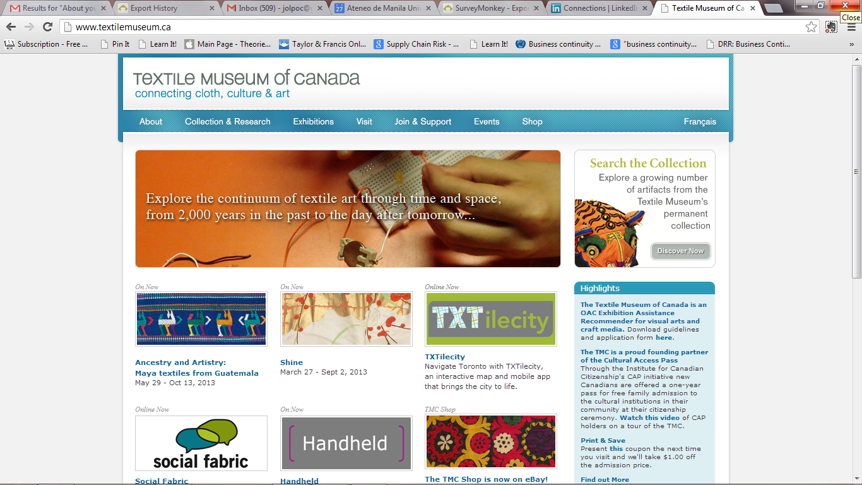

**Video Game Marketing**

**Most of the points in the strategic plan are targeted towards the adult to elderly population. Video games can be used as an effective tool to target the younger population.**

**Name of Recommender: Raymond JNC Cruz**

**New Museum Branch**

**Given Canada’s large size, a new museum branch opened in a distant area will make it more convenient for far-flung potential audience to experience TMC.**

**Name of Recommender: Raymond JNC Cruz**